Reviewer E:  
General comments  
=============  
This viewpoint addresses the issue of patient safety as it relates to digital health. While there is no doubt that this is an important issue that needs to be urgently addressed, there are several major issues that need to be addressed as outlined below.  
  
Specific comments  
=============  
Major comments  
---------------------  
1/ Literature review of patient safety: On pg 2 it is stated that there is, "no consensual definition” for patient safety when definitions and terms exist in the literature by international consensus[1, 2]. This literature needs to be carefully reviewed and incorporated into the manuscript.

\*We can remove the phrase “no consensual definition”. The ‘key concepts’ paper provides the follow definition for patient safety: “*the reduction of risk of unnecessary harm associated with healthcare to an acceptable minimum*”.

FYI, the ‘conceptual framework’ paper cited by the reviewer focuses on the development of a classification system for patient-safety concepts, in an explicit attempt to mirror the International Classification for Diseases system for diseases.   
  
2/ Literature review about the safety of digital health: Similarly, on pg 1, "It is currently unclear what the consequences are for patient safety as existing digital health technologies become ubiquitous with increasing pace and interact in unforeseen ways”. Again the literature in this area including a systematic review needs to be considered [3].

\*Fair comment. I’ve had the Kim, Coiera and Magrabi paper for a while so I don’t know how it didn’t make it into our manuscript. The inclusion of Kim paper undermines our stated justification for the workshop. We need to reconsider or restructure our justification to, perhaps, focus on the praxis of patient safety because the Kim paper and others have sorted the theory.  
  
3/ Gap: while it is clear that this is an attempt to summarise a workshop, it is not clear what gap this paper fills and how the challenges identified here build on those that were previously identified by the Sittig et al 2020 paper [4].

\*I think we have been pipped to the post by Sittig et al. A quick summary of the Sittig paper is that it presents “*nine key, short-term challenges to help…focus…efforts on* [HIT]*-related patient safety*…[c]*ategorized according to the stage of the* [HIT] *lifecycle where they appear*”. As each challenge is discussed, the authors provide suggested steps to overcome the challenges, similar to how we provided recommendations.

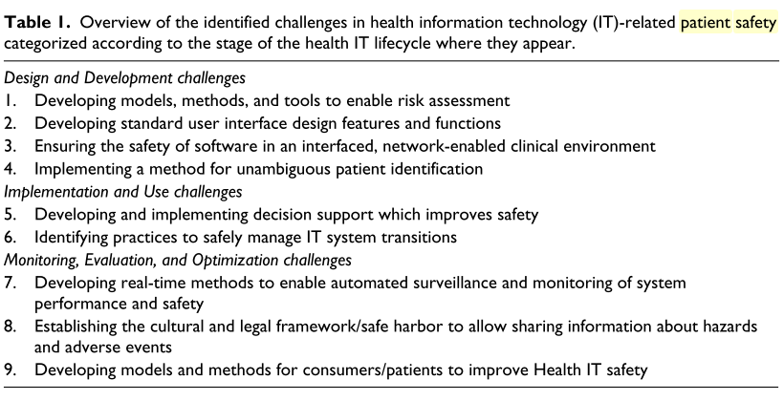

4/ The goal was to examine emerging digital health applications but the important area of AI safety is not mentioned.

\*The reviewer misunderstands our goal. Our focus was on the challenges posed by emerging HIT, not on detailing what the emerging HIT is because the latter has been done before.  
  
5/ Overall structure and argument: some more work is required to refine each of the challenges and recommendations with reference to the literature, and then explain them. For instance, it is not clear how safety cases can help in 'conceptualising digital threats'. It is not clear how the challenges were identified and if any process was undertaken to refine down to six.

\*With respect to safety cases, we might need to spend a little more time explaining them, but I was expecting the reader to do their own reading on the topic by following the citations.

With respect to identifying the challenge, yes this is a concern. The author is essentially asking u sot describe our method more. I worry that they expect us to have undergone some intention data-collection process, which we did not.  
  
6/ Table 1: please provide some examples applications to explain risk categories. This appears pretty useful to be a useful starting point but is not mentioned again in the paper.

\*We could integrate Markus’ framework into description of our challenges.

References  
1. Runciman W, Hibbert P, Thomson R, Van Der Schaaf T, Sherman H, Lewalle P. Towards an International Classification for Patient Safety: key concepts and terms. Int J Qual Health Care 2009;21(1):18-26 doi: mzn057 [pii]  
10.1093/intqhc/mzn057 [doi][published Online First: Epub Date]|.  
  
2. Sherman H, Castro G, Fletcher M, Hatlie M, Hibbert P, Jakob R, Koss R, Lewalle P, Loeb J, Perneger T, Runciman W, Thomson R, Van Der Schaaf T, Virtanen M. Towards an International Classification for Patient Safety: the conceptual framework. Int J Qual Health Care 2009;21(1):2-8 doi: mzn054 [pii]  
10.1093/intqhc/mzn054 [doi][published Online First: Epub Date]  
  
3. Kim MO, Coiera E, Magrabi F. Problems with health information technology and their effects on care delivery and patient outcomes: a systematic review. J Am Med Inform Assoc. 2017 Mar 1;24(2):246-250. doi: 10.1093/jamia/ocw154. PMID: 28011595; PMCID: PMC7651955.  
  
4. Sittig DF, Wright A, Coiera E, Magrabi F, Ratwani R, Bates DW, Singh H. Current challenges in health information technology-related patient safety. Health Informatics J. 2020 Mar;26(1):181-189. doi: 10.1177/1460458218814893. Epub 2018 Dec 11. PMID: 30537881; PMCID: PMC7510167.

------------------------------------------------------  
  
  
------------------------------------------------------  
Reviewer M:  
General comments  
=============  
This paper: This is a view point article on an important emerging subject but needs some revisions.   
  
Specific comments  
=============  
Major comments  
---------------------  
1.methods should be explained more: authors stated that the definitions and challenges have been extracted from current literature, a series of experts’ workshops and their clinical, professional and academic experience. All of these should be explained in more details. \*I think we will always be caught by this. We did not have a rigour method. We had a meeting and wanted to produce a paper. If we had wanted to produce a paper, we would have structured the meeting as a data collection and synthesis session, which would have looked different. JB has suggested that we could write an article in a qualitative methodological style, but CMI does not feel able for this.  
2.The recommendations presented in table2 need to be explained more clearly as some of them are not understandable specifically for example recommendation for the challenge number1. (Systems approach to conceptualising riskT; Safety  
Cases?; Sociotechnical perspective) is not clear. Also, the recommendations made here are not specific, authors proposed a system-approach/sociotechnical perspective for the majority of identified challenges. Using system-approach is a broad recommendation which can be proposed for different challenges in different systems, while readers want to see the specific recommendations of authors. So, authors have to adopt system approach for each identified challenge and clearly provide the system-approach suggestions for that challenge. For examples authors should explain that if the “trust between care receivers and care providers” could be harmed by using emerging information technologies then they should clarify that what system-approach says for solving this challenge.   
3.Check the citation Throughout the manuscripts, importantly check these 2 issues:  
- A main body of manuscript have no citations, \*I don’t understand; there are citations throughout.  
- Some parts of manuscript seems to need no citation while include citations such as “ We also recommend that regulators and developers of standards adopt a systems approach to conceptualising risk to appropriately reflect the complex adaptive nature of health care .[37]” if this is an authors’ suggestion does not need citation or this one :” The intention of this paper was to begin the process of developing the theoretical and practical foundations of Patient Safety Informatics, answering calls for practical progress in safety science.[75]” \*I think this is a style issue. I had cited the papers for further reading rather than as the sources of the idea.  
4. Challenge number 5 is not understandable for me. Authors have proposed “Emergent patient-safety consequences” as a challenge of digital health. I think at least a revised Title and also a more clear definition and explanation of this challenge are needed for this challenge.  
5. What do you mean by beginning the process of developing the theoretical and practical foundations of Patient Safety Informatics as the study objective?   
6.Authors have stated that they have proposed theoretical and practical mitigations for the identified solutions. They have to define theoretical mitigations and practical mitigations.   
7.If applicable add the “ethical considerations” and “study limitations and strengths”.   
  
...  
  
Minor comments  
---------------------  
1. table 2 should be reformatted \*More information needed. The formatting was in accordance with the guidance of the journal.  
2.Matching the challenges titles introduced in table2 and text is suggested \*I don’t understand.  
  
------------------------------------------------------